Assignment – 4
Azure Cloud Fundamentals and Data Pipeline Implementation using ADF

Task – 1:
- Explored azure portal
- Created a resource group by clicking on resource group tab => create new
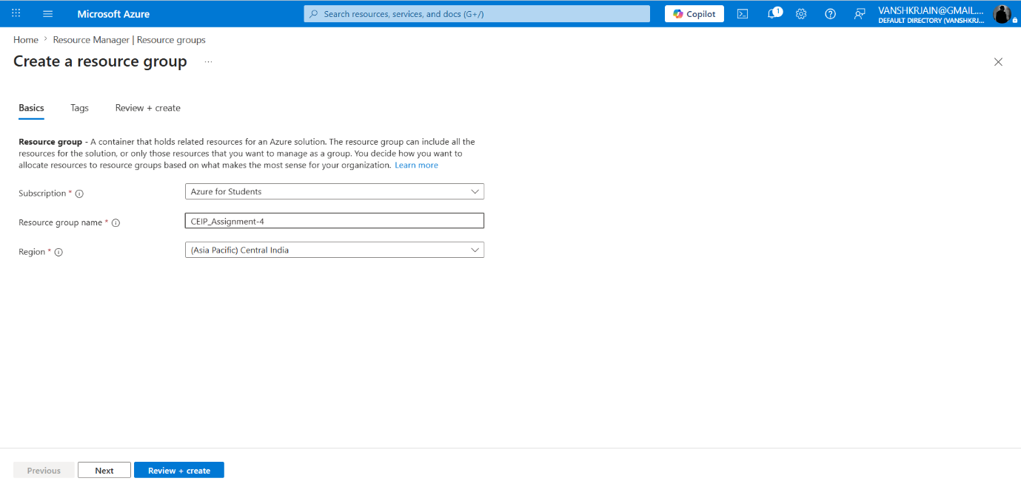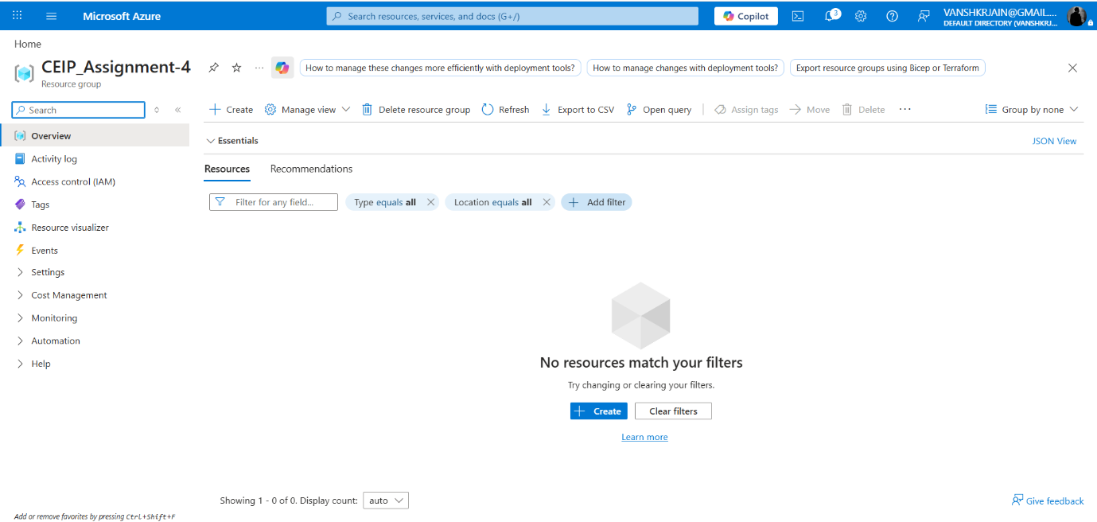

Task – 2:
- Click on storage tab => create new
- Click on container in left selection panel => create two containers named raw_date, copied_data
- Upload the csv file (sample-superstore.csv) in raw_data container
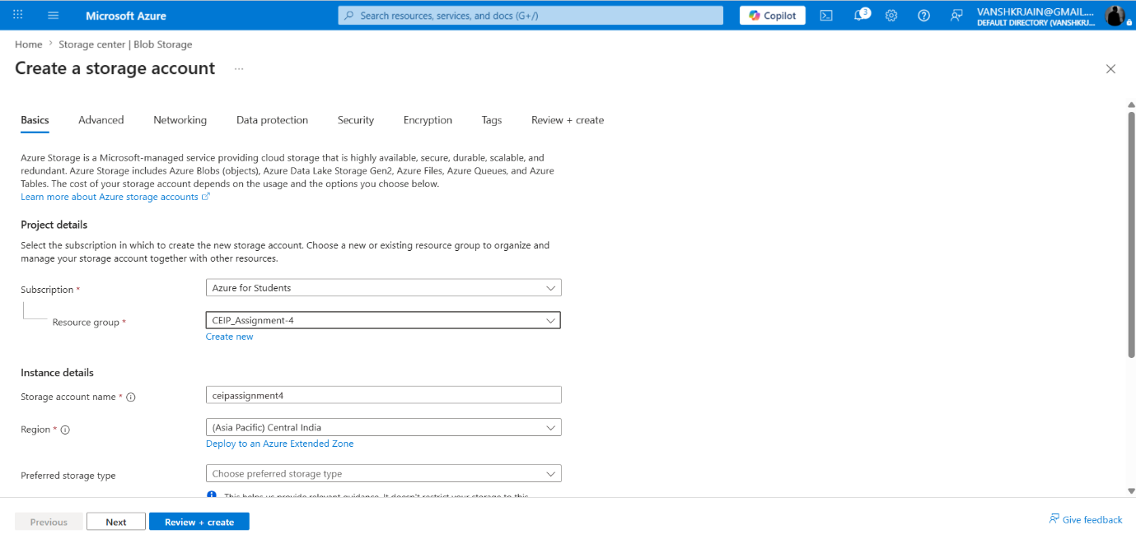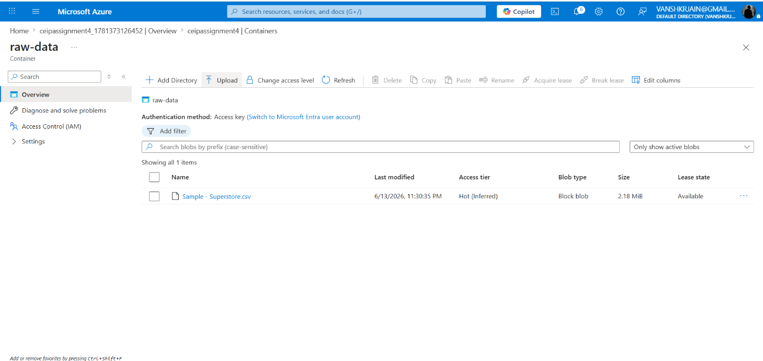

Task – 3:
- Click on azure data factory tab => create new
- Click on manage => linked service => create new
- Click on author => dataset => create two new datasets (soure, destination)
- In author tab select pipeline => drag and drop get metadata activity to canvas
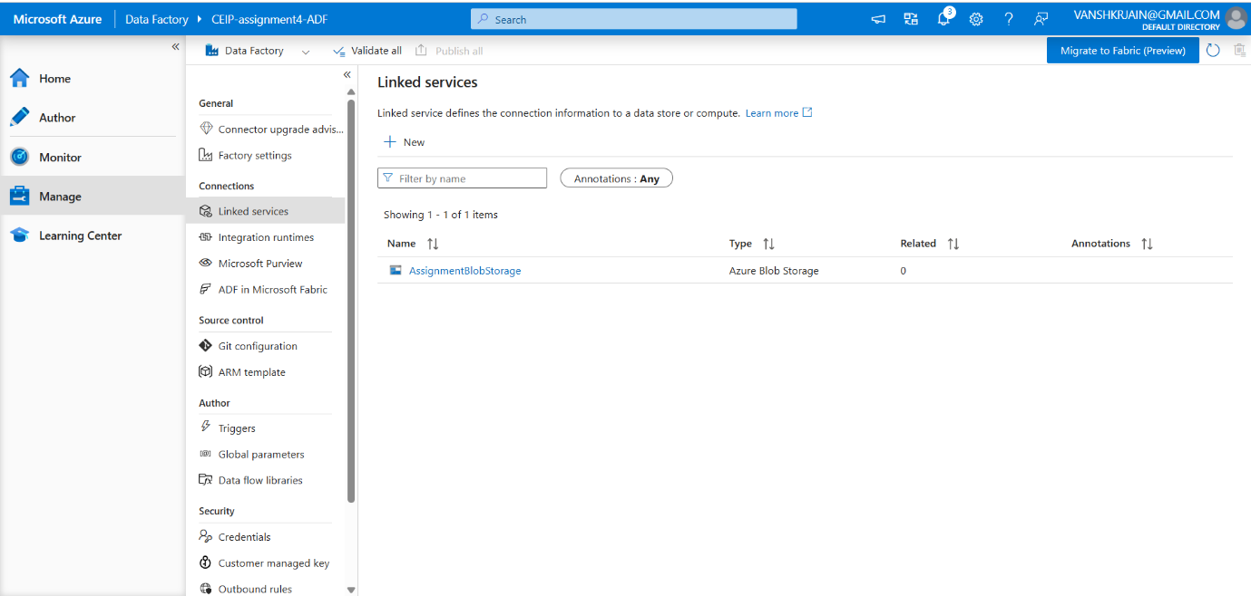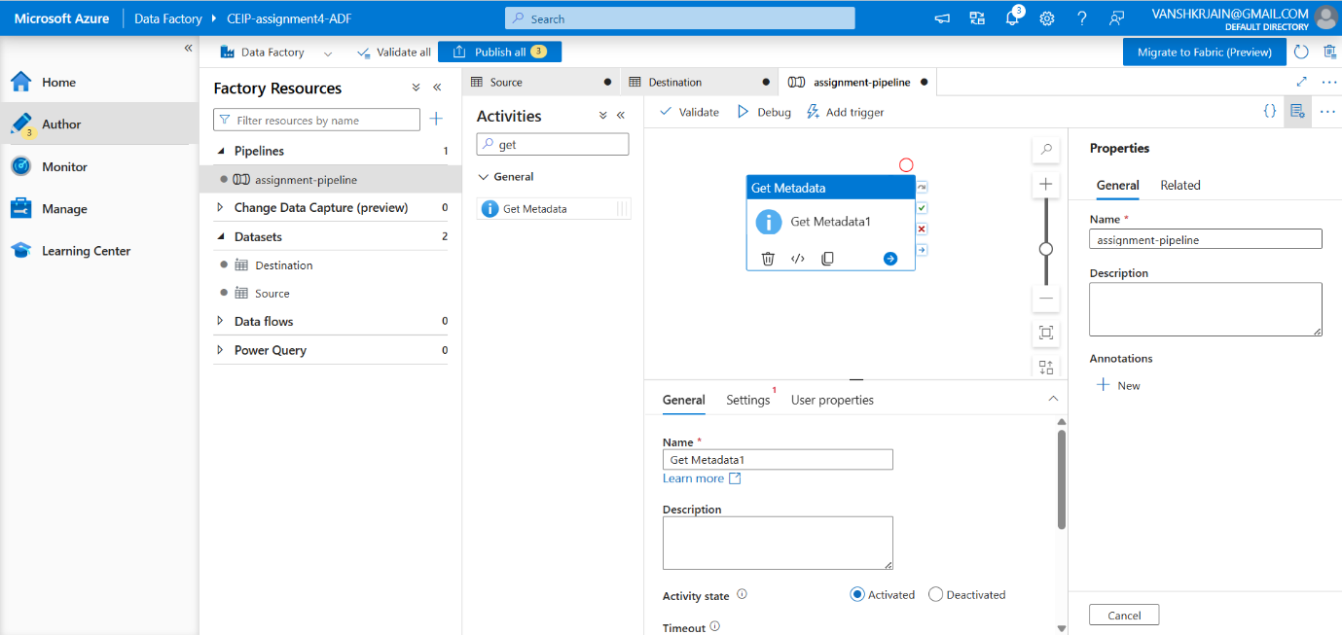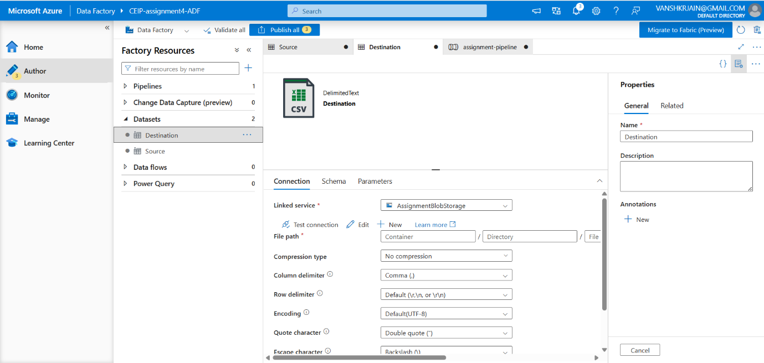

Task – 4:
- Drag and drop copy data activity to canvas
- Connect get metadata with copy data activity
- Configure source and sink locations in copy data activity
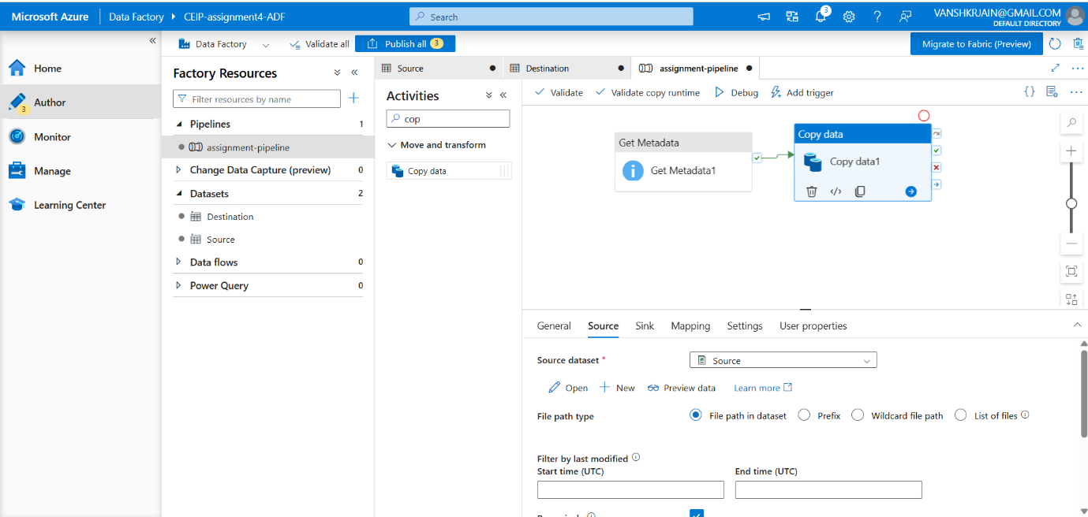

Task – 5:
- Click on bebug button placed above the cancas to run the pipeline
- Click on monitor tab to view execution sequence of your pipeline
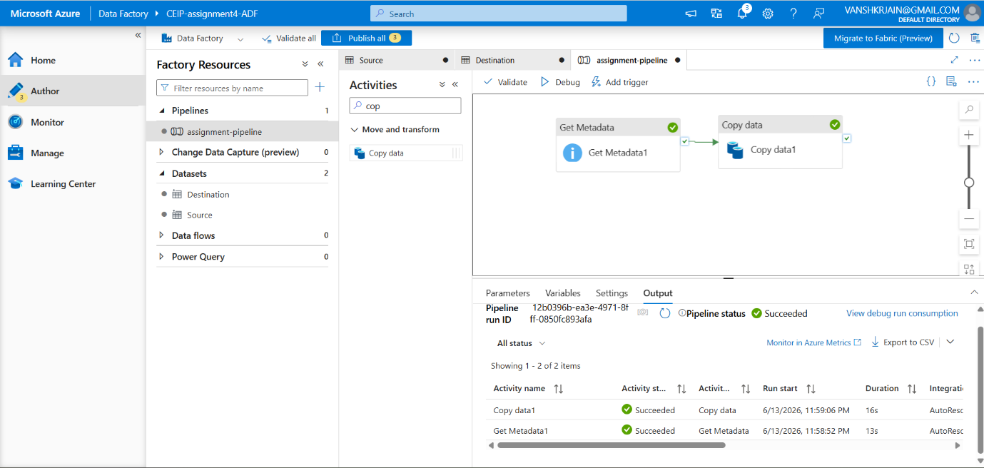

Task – 6:
- Go to resource group tab => Identity and access management (IAM) => create new
- Search reads => reader => assign member
- Search contributor => contributor => assign member
- Go to data factory => open your data factory => go to settings in left menu => click identity
- System Assigned Managed Identity => On
- Go to storage account => Access Control (IAM) => Add Role Assignment => Storage Blob Data Contributor => Select Members => Data Factory
